**Read before grading as my fork command might be confusing without reading**

Okay, Gusty, here we go – HUGE disclaimer before we get started on grading this here project

So, I’ve unfortunately committed the age-old sin of waiting too late to start on the project, and ergo, I have not completed it in its entirety (also I’m accidentally turning it in an hour late because I thought it was due at midnight, that’s on me.) I am missing test cases, and the schedule call returns a floating-point exception, but as I am running out of time to get it in, I am presenting what I have.

HowEVER, I do have quite a lot of things included in the project. I was doing the Linux Completely Fair, and I can talk about the CFS for literally hours because I understand that guy in SO much depth. I ran into some trouble implementing it though because we are doing a simulation, and so the processes aren’t actually running and giving us dynamic runtimes. This means that I had no way of knowing when a process is finished running and when to remove it from the red-black tree (I will discuss this bad boy in the next paragraph.) So, I made an assumption, and I required the user to input a “time to completion” value when they forked a process, aka, how long the process would need to be run before it was totally done. I thought it was important to include this because I wanted to demonstrate that I understood the CFS concept of making the time slices bigger once the number of processes waiting to run decreases. Additionally, I’ve asked the user to input the priority of their forked process but in weight form because I ran out of time to make a corresponding table. Finally, the last parameter is the parent, which was part of the fork process originally. So when executing the fork command, the format is:

$$fork \left[time to completion\right][weight\left(optional\right][parent(optional)$$

I hope making these assumptions was okay!

Okay, red-black tree time. I didn’t submit it in my notes picture, but I have Eighteen Whole Pages of notes I’ve taken about red-black trees, and I’ve pretty much mastered inserting and deleting nodes from one hahaha. I’ve submitted my algorithms (I think) for how the code of it will go, but I unfortunately had to use code from Programiz[1] to do the insert and deletion functions because I ran out of time. This is the only plagiarizing I have done however, so I am giving her the credit she deserves. Thank you Programiz gods.

Okay that’s pretty much all, I’m disappointed in myself for not starting this earlier, but I’m proud that I’ve been putting my labs in pretty much on time and staying on top of those this semester! Megan and I have also already started looking at the Shell Project so this does not happen again, planning ahead planning ahead.

Thank you for all the leniency you have given me over this academic year, and I hope you know how deeply I appreciate the kindness and in no way, shape, or form take it for granted. Being in your class has been a joy, and I’m looking forward to the rest of the semester!

Schedule Project – Answer Document

Submissions

1. Place the design of your implementation in this item. You should study the problem and create a design before trying to modify the code.
   1. Place diagrams of the data structures and how they are related here.

Data Structures outline:

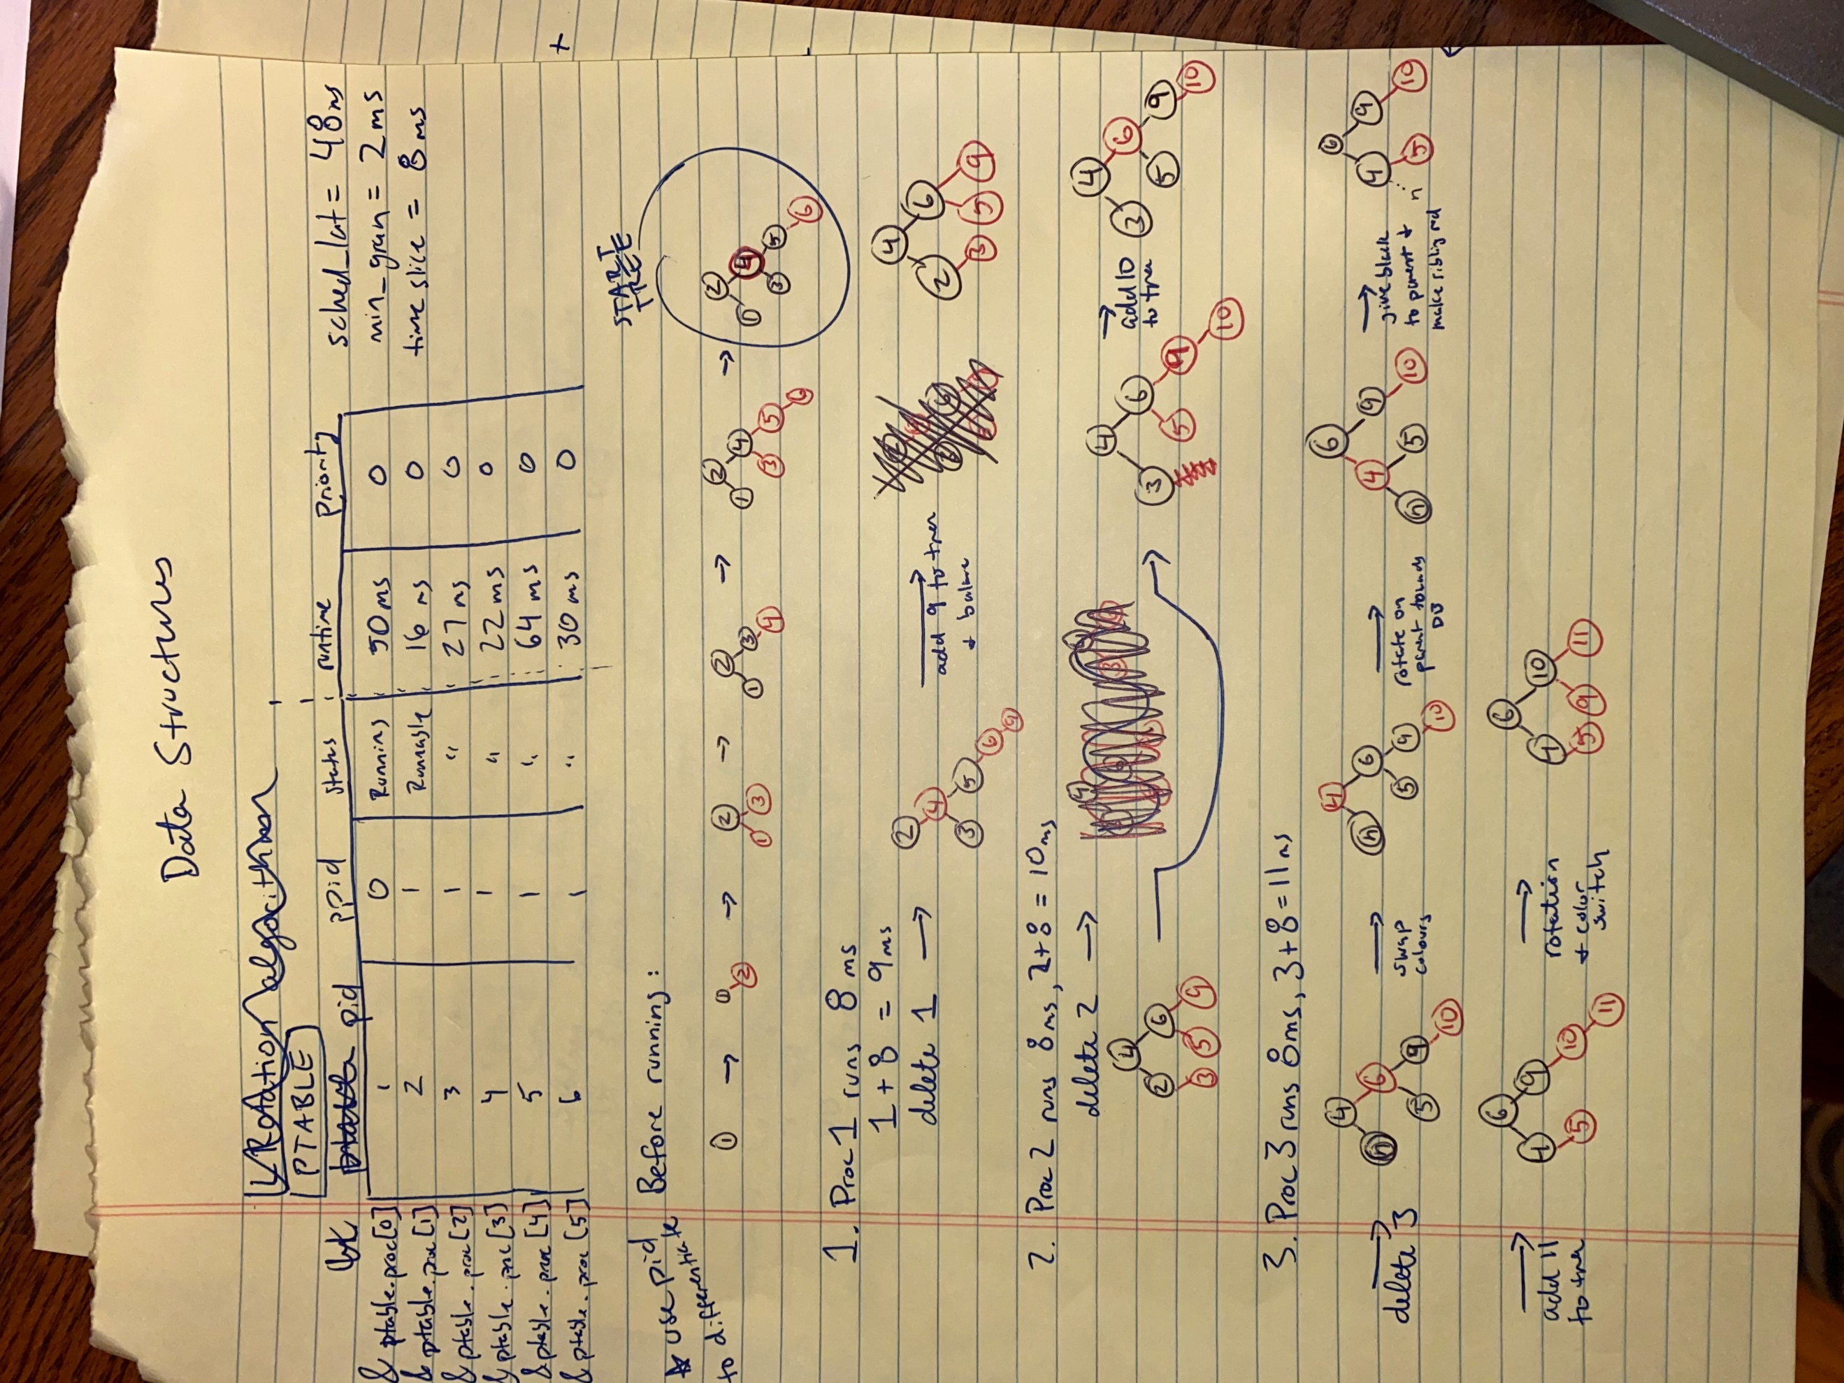

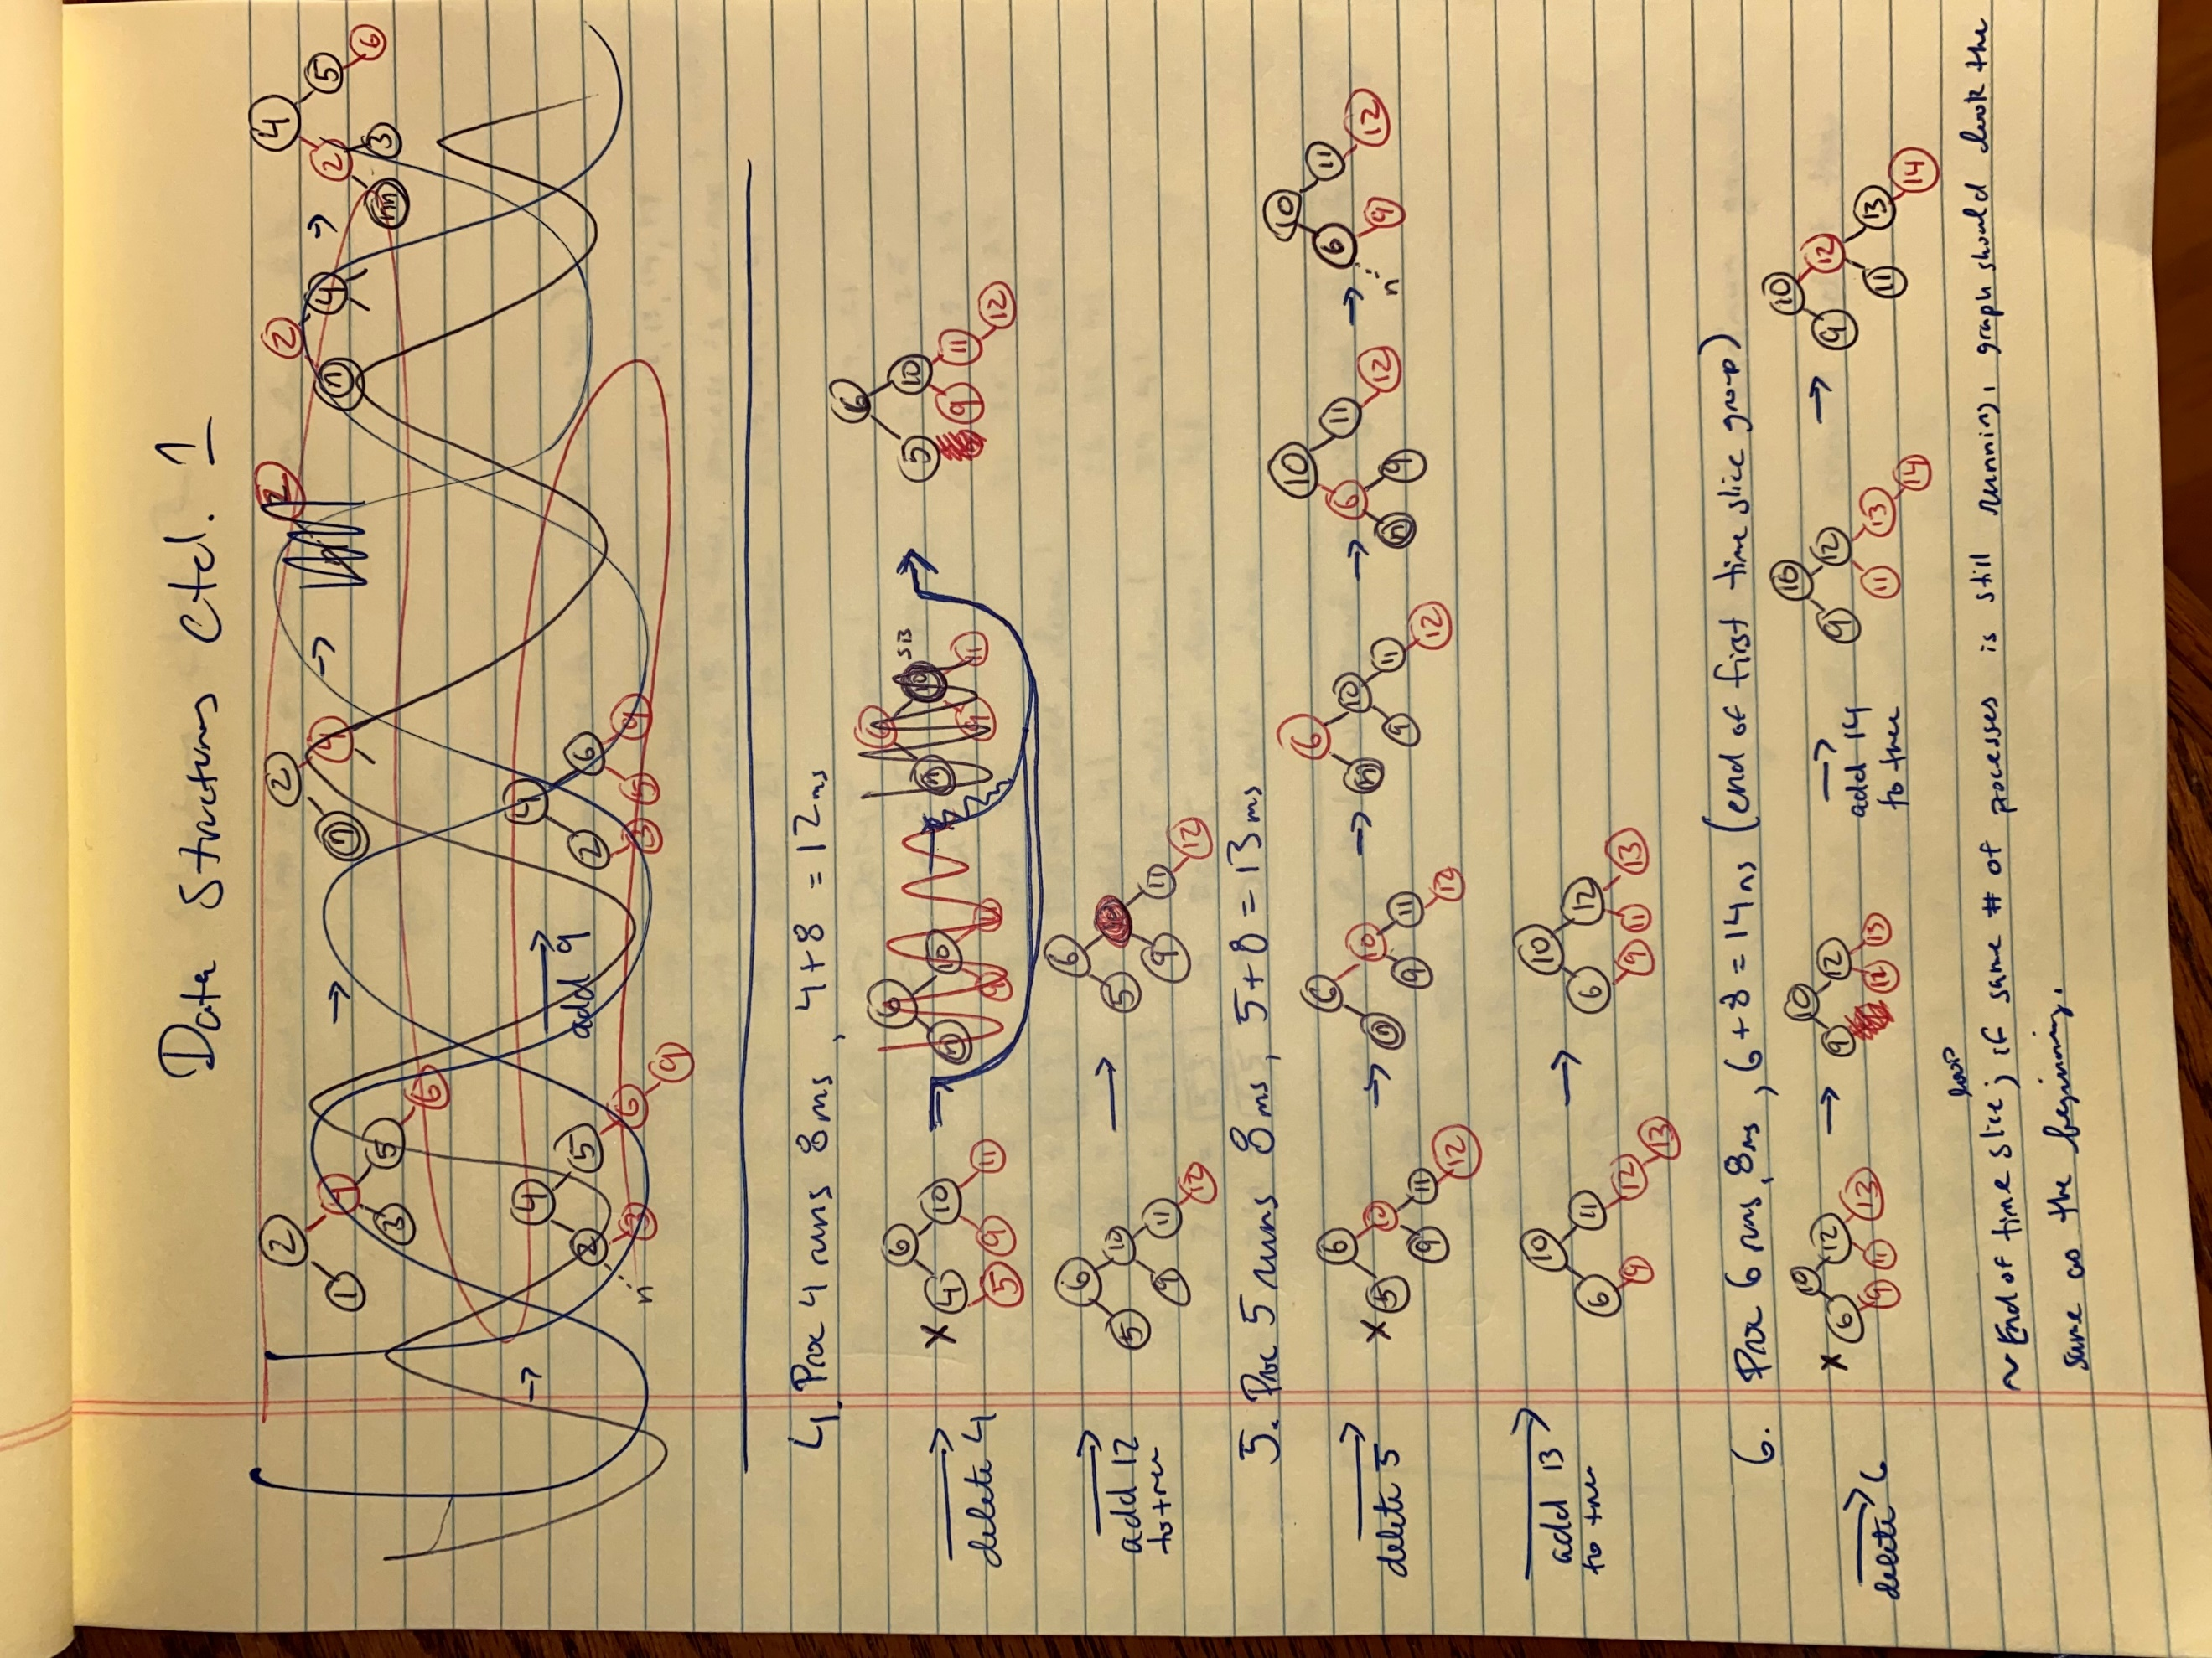

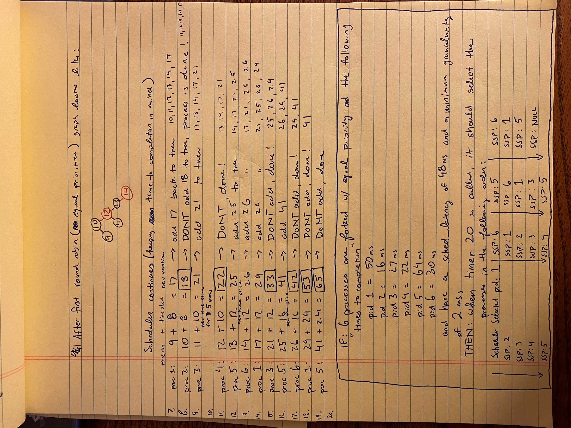

* 1. Place pseudo code of your algorithms and how they affect the data structures here.

Insertion algorithm:

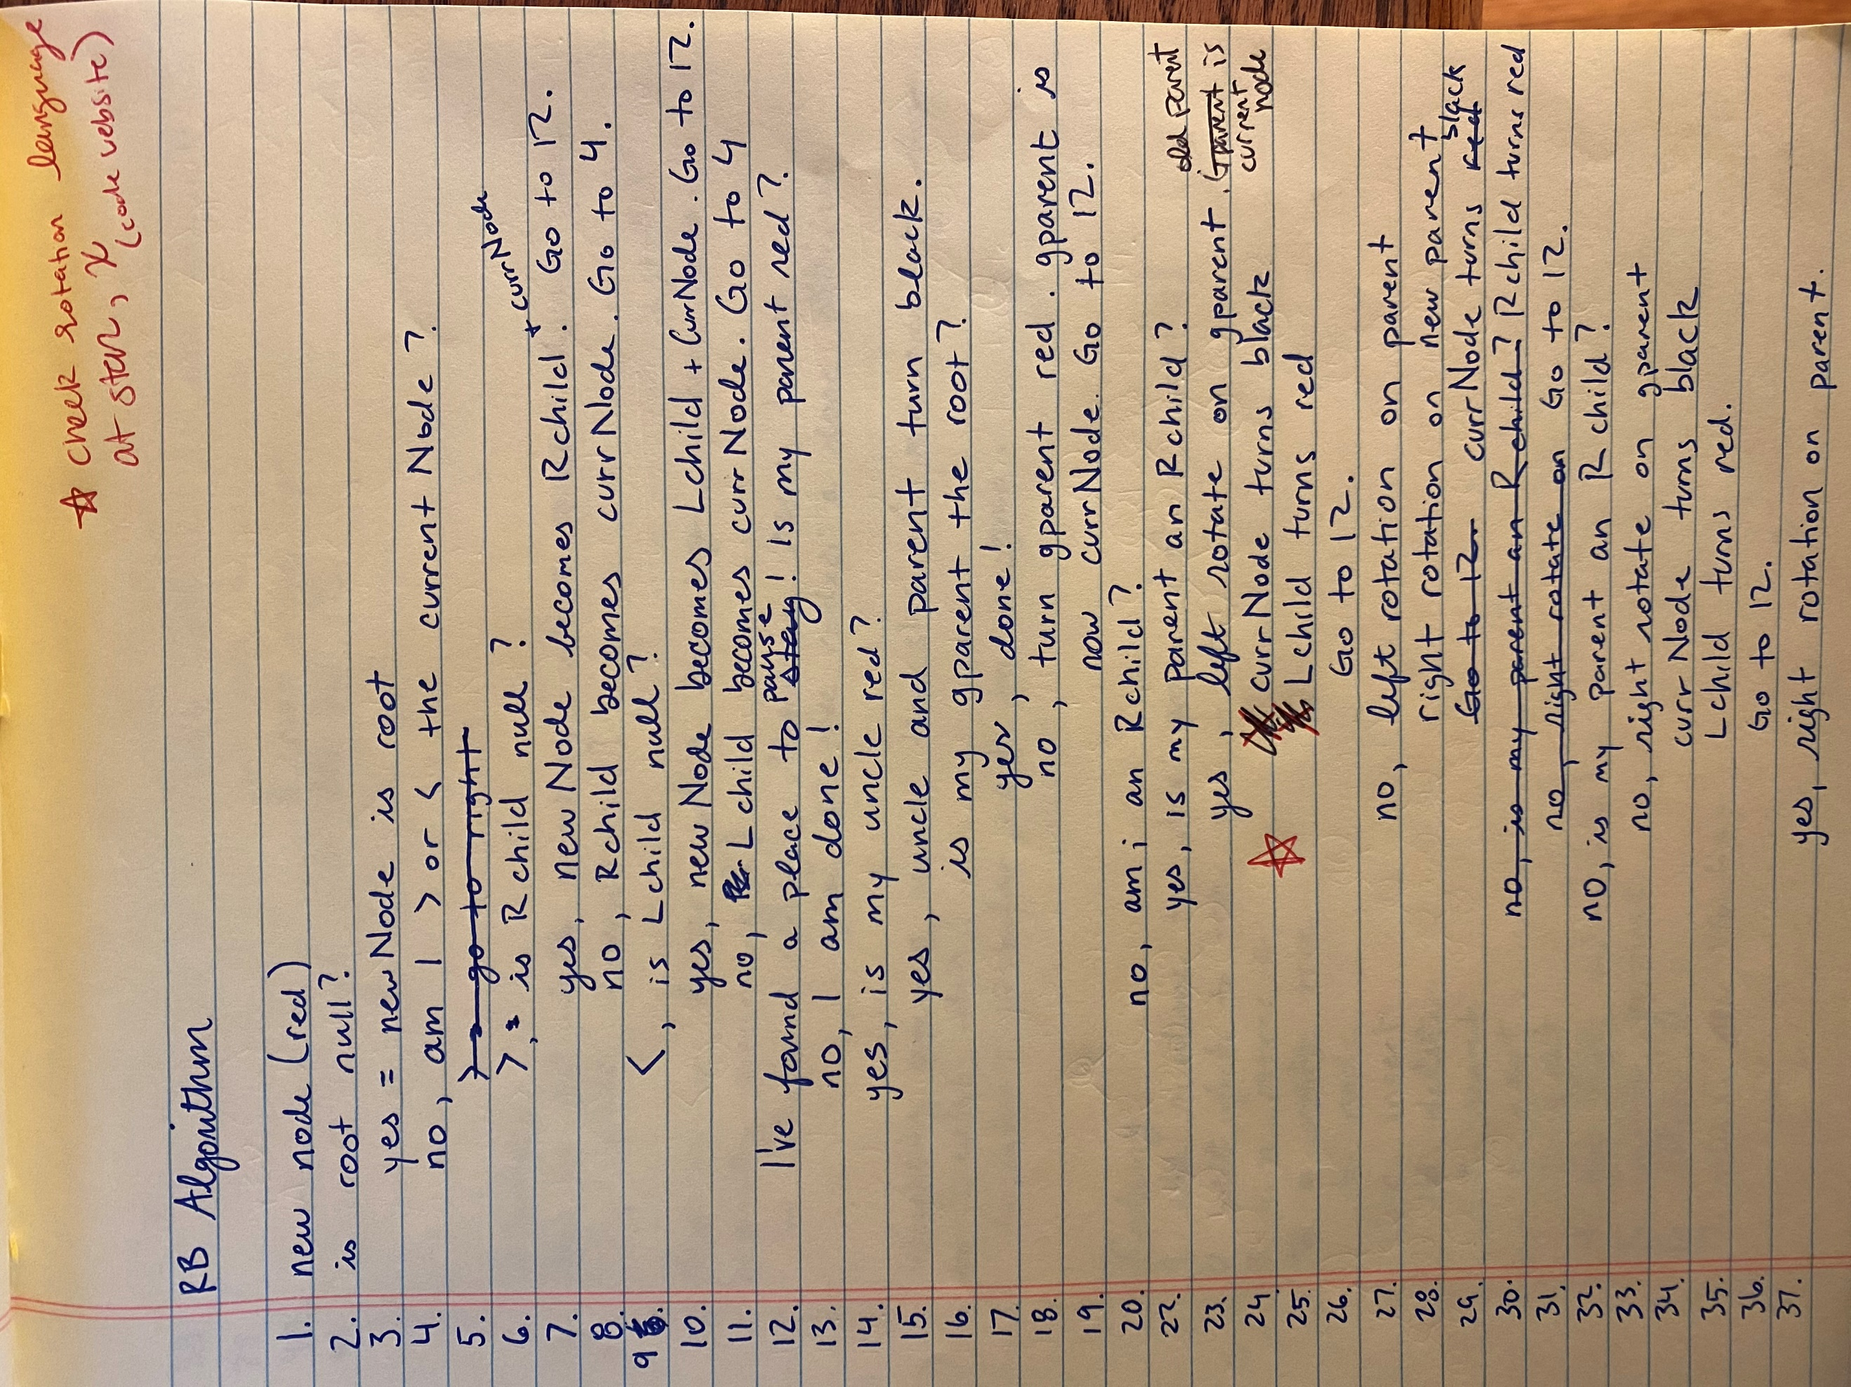

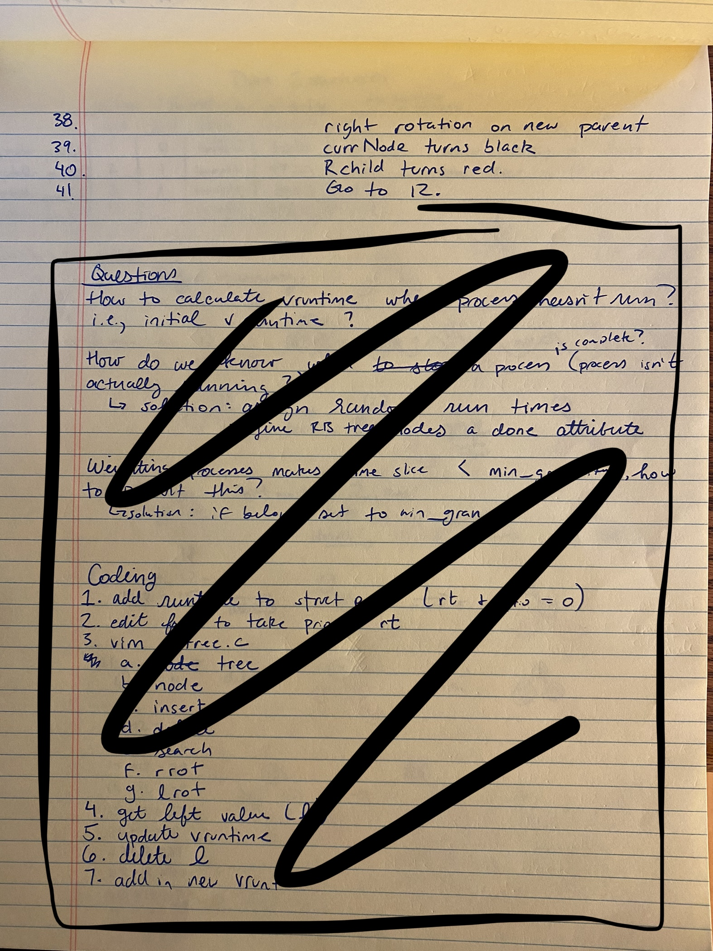

Deletion cases/notes:

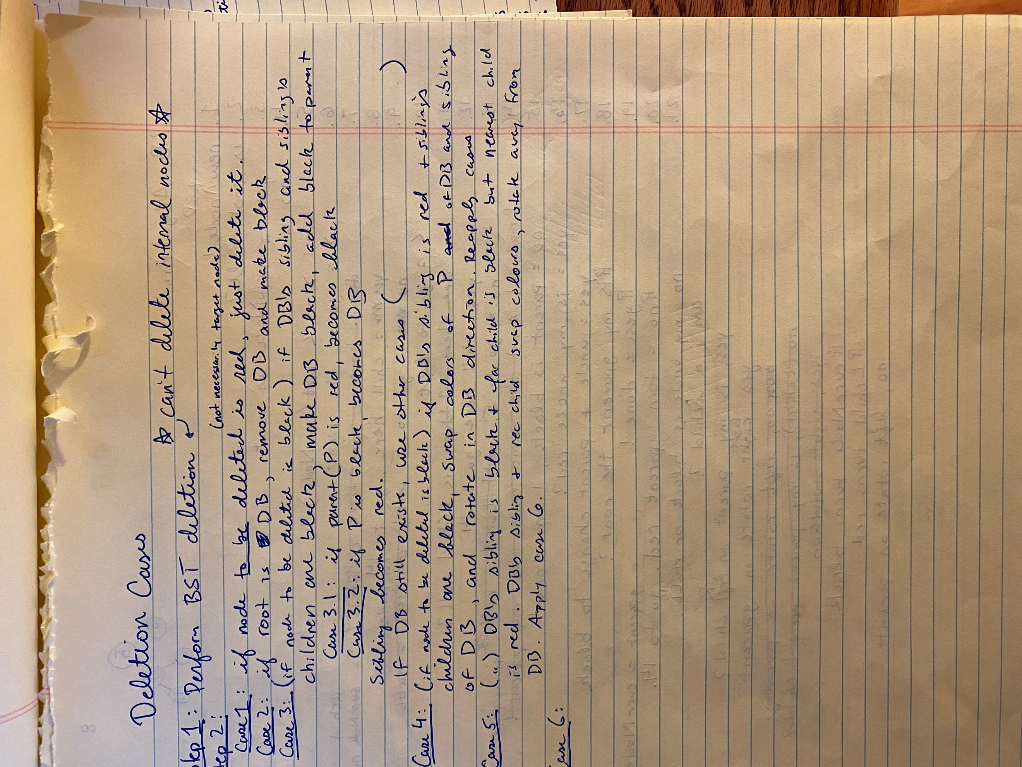

Left most node and Schedule loose pseudocode:

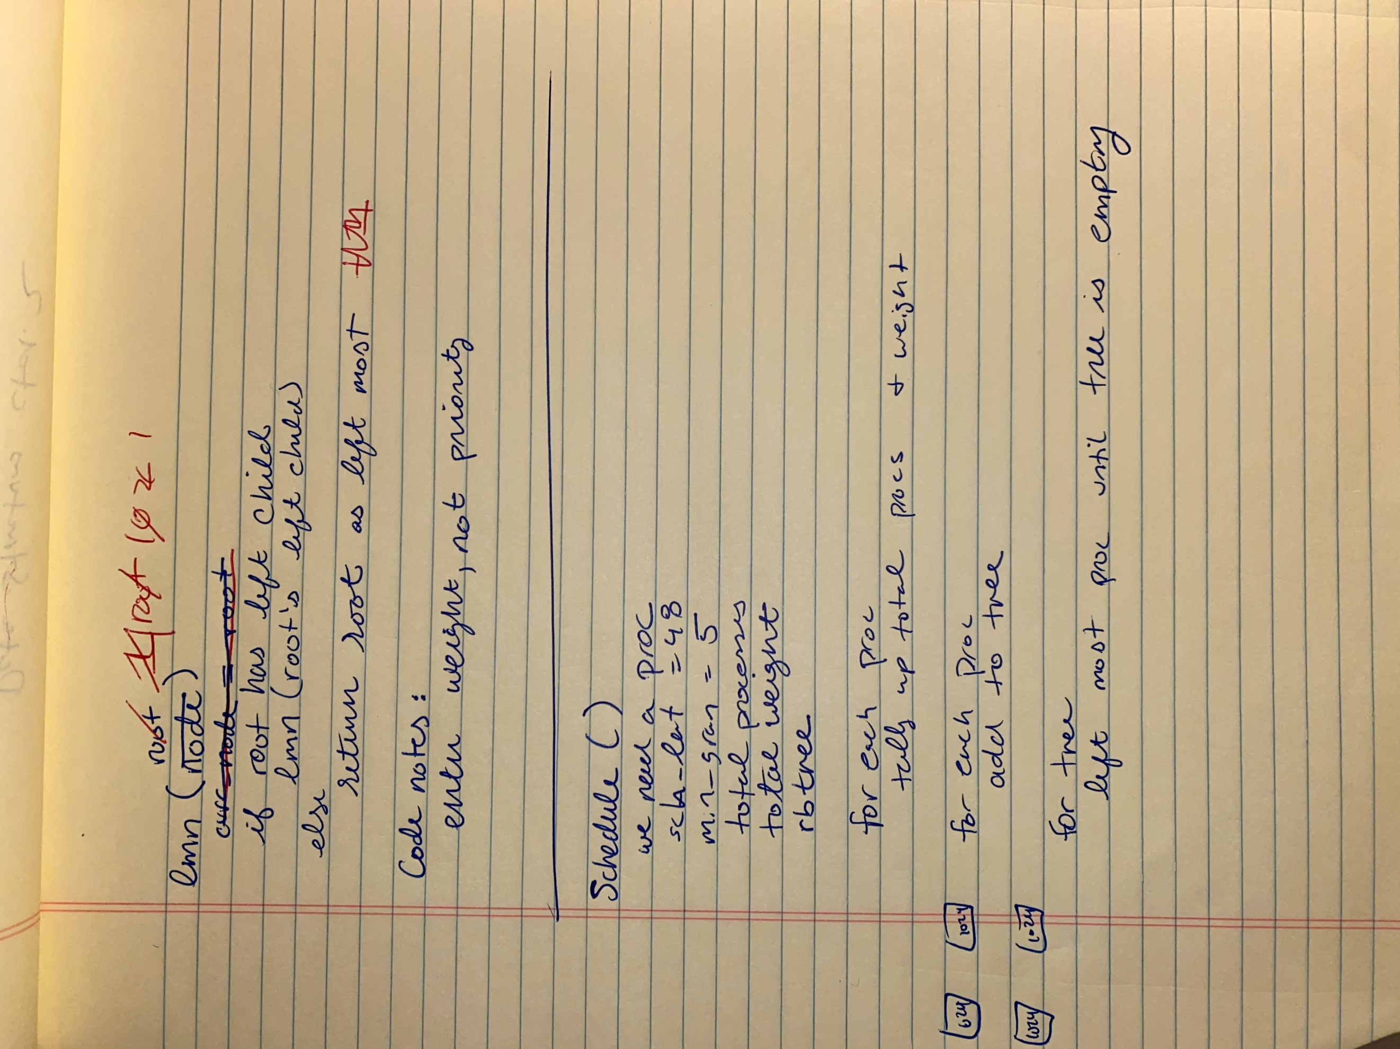

* 1. Place a list of source files in the code base that you updated.

defs.h

main.c

proc.c

proc.h

rbtree.c – this is the rb tree code I started making myself but ran out of time

rbt.c – code from Programiz

1. Place your test cases here. Your collection of test cases should demonstrate you have tested the entire program. You will have a collection of test cases for each of you schedulers. For each test case, first describe the objective of your test case. Then  insert a copy/paste of you applying your test cases to your program. The copy/paste must demonstrate that actual output achieved the described objective.

a sad empty section :(

1. On Canvas submit the code (.c, .h, and makefile) for your two scheduling algorithms. You must submit all code, even code that you did not modify. Your modified source files must include comments in the code that describes your modifications. If you implement two programs - one for each scheduler, you should submit two zip files - one for each solution.

1. https://www.programiz.com/dsa/deletion-from-a-red-black-tree